MINI PROJECT

# CRIC INFO: cricket related contents

# LINK: https://www.figma.com/proto/cSERXQ0b1uVQetMjzCZQef/project?node-id=3-18&starting-point-node-id=3%3A18&t=WA056w7oo9NK6Kuh-1

**ABSTRACT:**

**CricInfo is a real-time coverage of cricket matches globally. This platform offers cricket enthusiasts a one-stop destination for live scores, ball-by-ball commentary, player statistics, news, and analysis. With a user-friendly interface and a commitment to providing up-to-the-minute information, CricInfo has become a go-to resource for cricket fans seeking a dynamic and engaging experience during live matches. This abstract highlights CricInfo role in bridging the gap between cricket enthusiasts and the latest updates in the world of international and domestic cricket.**

# FRAMES DESCRIPTION:

## Welcome Screen:

* Minimalist design to create a positive first impression.

## Login:

* Give username as your wish
* Put your mobile number
* And give strong password
* These things are useful for survey

## Table:

It useful for see the table toppers and check run rates

## Schedule:

* List of the matches with its date and time.

# DESIGN:

# 



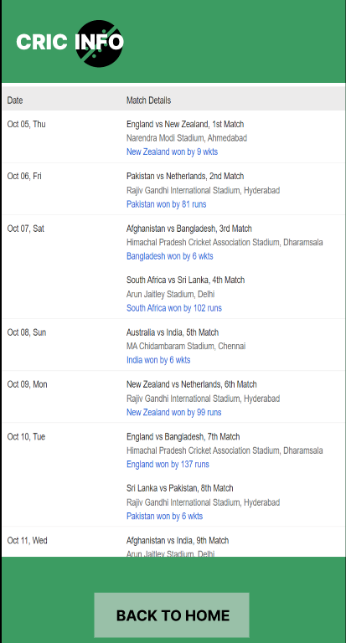

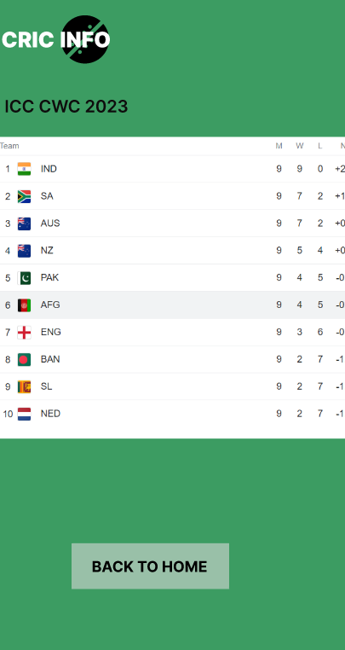 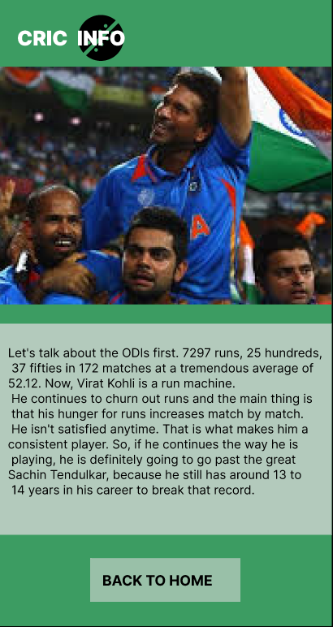

**CONCLUSION AND FUTURE ENHANCEMENT:**

Advanced Statistics and Analytics:

Provide more in-depth statistics and analytics for players and teams, such as advanced metrics, player performance trends, and predictive analytics.

Integrate machine learning algorithms to offer insights into player form, match predictions, and other statistical analyses.

Interactive Fan Engagement:

Develop features that enhance fan engagement during live matches, such as interactive polls, quizzes, and live chat forums.

Integrate social media feeds to allow fans to discuss and share their thoughts on the platform.

Enhanced Mobile Experience:

Continuously optimize the mobile app for a seamless and user-friendly experience.

Consider features such as offline access to articles and videos, push notifications for live match updates, and faster loading times.